FINAL PRODUCT BREAKDOWN

TEAM: [State Team number and Name here]

Due Date:
Friday, March 27, 2020 at 11:59pm

Provide several pics of the completed system here:
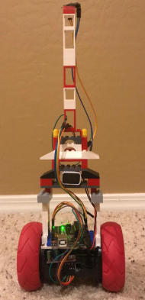
Figure 1: Final Product

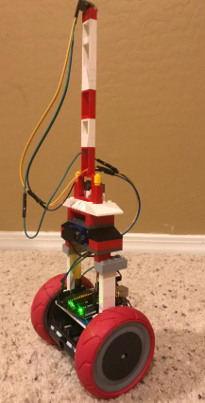
Figure 2: 3D View of Final Product

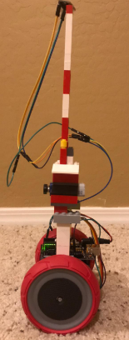
Figure 3: Side view of Final Product

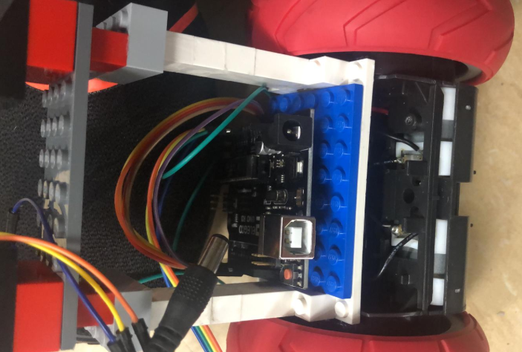
Figure 4: Central Part with the Arduino Controller

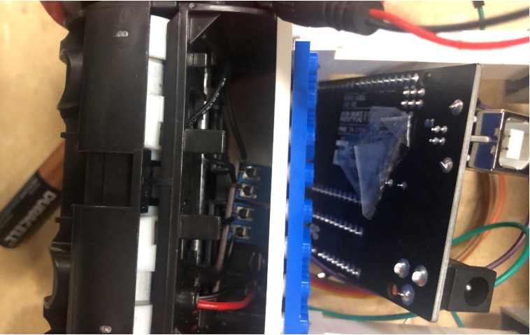
Figure 5: Base structure with motors

The following are the Action Items each person completed between Hardware Review 2 and the completion of the final product:

Team Member: Fahad Alostath
Action Item | Date Completed | Result/Proof of Completion
Written the Arduino Code | 03-03-2020 | 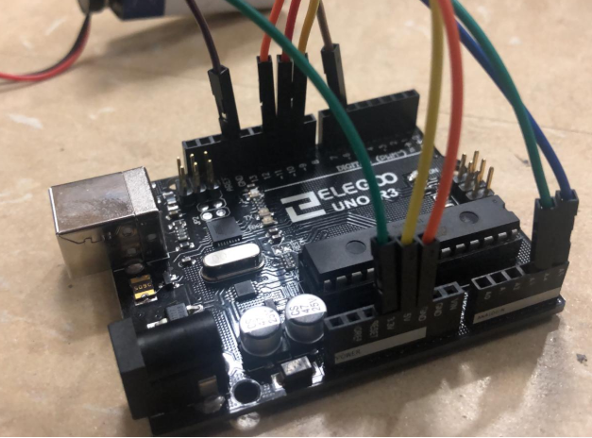
Connected Batteries | 03-05-2020 | 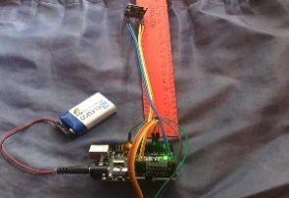
Developed Structure | 03-10-2020

Team Member: Naif Alfihan
Action Item | Date Completed | Result/Proof of Completion
Setup Connection for Accelerometer | 03-03-2020 | 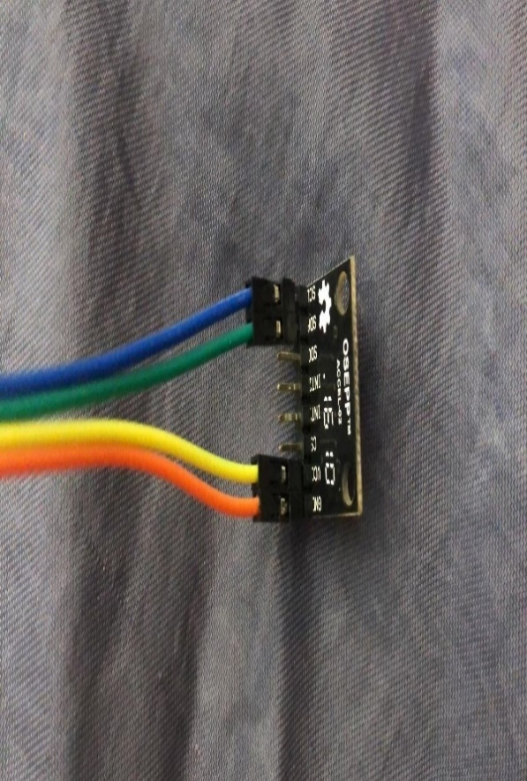
Setup Connection for Gyroscopes | 03-05-2020 | 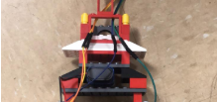
Developed the Body Structure | 03-10-2020

The following are the Action Items for each team member between the Final Product presentation and the Testing Proof:

Team Member | Action Items | Date Due
Fahad Alostath | - Arduino Code  - Connected the Batteries  - Motors Connections | - 03-03-2020  - 03-05-2020  - 03-10-2020
Naif Alfihan | - Setup the Connection of Accelerometer  - Setup the Connection of Gyroscopes  - Developed the Body Structures | - 03-03-2020  - 03-05-2020  - 03-10-2020

